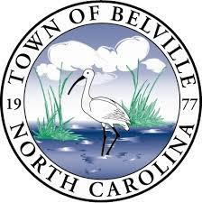

Town of Belville

Parks and Recreation Department

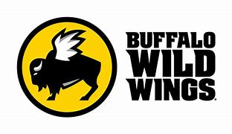
  - Fundraiser for Future Belville Riverwalk Park Playground/Park Upgrades
The Town of Belville Parks and Recreation Department would like to invite you and your family out for dinner and watch some Monday Night Football between the Cardinals and 49ers to help support our department raising funds for our new playground equipment and future park upgrades at our Belville Riverwalk Park.
10% of all sales will be donated back to us so please invite everyone you know to come enjoy great food and atmosphere for this night!!
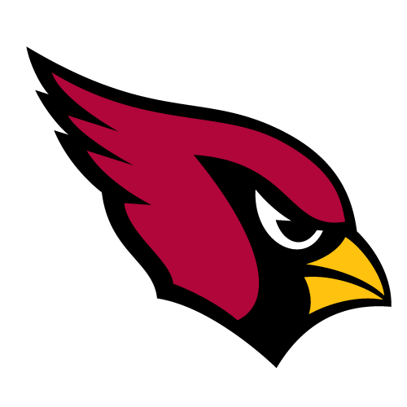
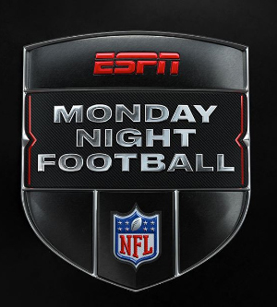
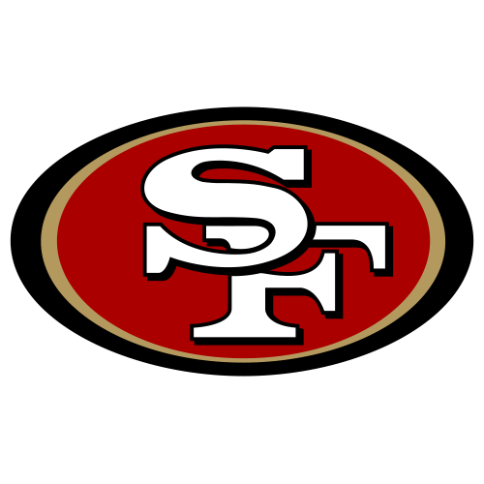

Monday, November 21st 5:00p.m – 9:00p.m.
Buffalo Wild Wings Monkey Junction
5533 Carolina Beach Road, Wilmington, NC 28412

