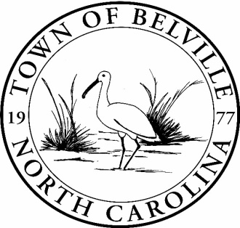

3rd Annual Belville Youth Fishing Day
RULES
Participants must be between the ages of 6 to 15 Years of Age.
Open to Brunswick County residents only.
One parent/guardian will be allowed on the pier with their child.
First 36 Participants registered in all age groups will be entered.
One (1) fishing rod and reel will be furnished per child with bait and tackle included.
It is a catch and release event.
If a parent/Guardian brings a rod to fish, they must have a valid fishing license.

NAME: _______________________________________________Age: _____________ Birth Date: ____________

Address: ____________________________________________________________________________________

City: ____________________________________________State: _________________Zip: ___________________

Contact Phone Number: _______________________Email: _____________________________________________

Parent/Guardian Signature: _________________________________________________Child’s Shirt Size_____________

(12) 7:30am until 8:45am (12) 9:15am until 10:30am (12) 11:00am until 12:15pm
Disclaimer:
I, ______________________________________, confirm the above information is correct and I assume all responsibility of my child during the Youth Fishing Day. I have read, understand, and agree to abide by the 2022 Youth Fishing Day Rules of the Belville Parks and Recreation Board and the Town of Belville.
I, ________________________________________, Parent/Guardian, consent, and grant permission to use the above participants photo(s) for the Town of Belville website and Facebook page.

